

Site Team Porter

Information Pack
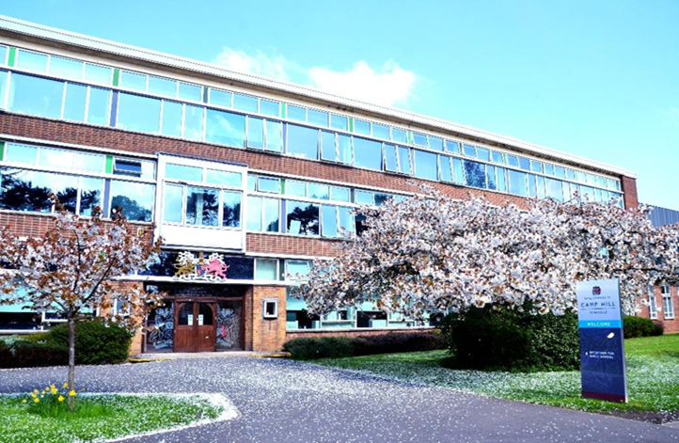

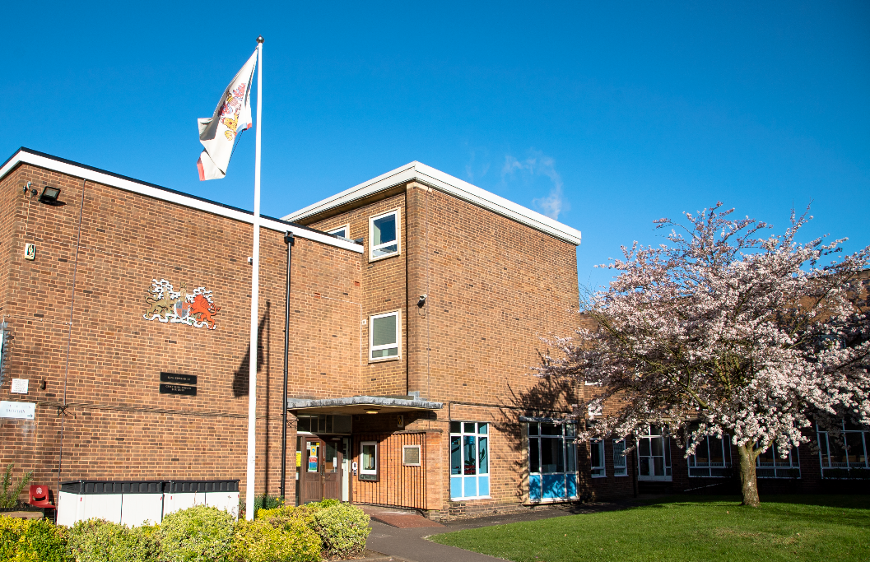

Dear Candidate,
Thank you for requesting information about our Site Team Porter.
We are forward thinking, selective state grammar schools with academy status, and belong to the King Edward VI Foundation of schools and Multi Academy Trust.
Aside from our desire for our students to excel academically at KEVI Camp Hill School for Boys & Girls, we place great importance on their happiness and the development of them as individuals. By providing a full range of quality experiences both in and outside of the classroom, our students develop confidence, resilience and learn to make healthy choices - all of which helps to prepare them for life beyond school. Every single member of staff and the student bodies play their part in adding to the history of the schools. We are very privileged to lead outstanding teams of colleagues. Their hard work, extensive subject knowledge and commitment to ensuring the academic results are outstanding, enabling our students to make excellent progress as they move through each of the schools.
Camp Hill Girls & Boys are culturally rich and diverse, welcoming students from an extraordinary range of backgrounds. As school communities we recognise, celebrate, respect and delight in our differences, and use them as opportunities to learn and become more tolerant about the world around us.
We believe the KEVI Camp Hill Schools are inspirational places to be, and invite you to come and see for yourselves. We very much look forward to welcoming you to our schools.
Karen Stevens Russell Bowen
Headteacher Headteacher
KEVI Camp Hill School for Girls KEVI Camp Hill School for Boys

King Edward VI Camp Hill Schools Site Team Porter Job Description

Role: Site Team Porter 36.5 hrs a week
Salary: SCP 13-15, £29,064 - £30,024
Working Pattern: Working 5 days in 7, 36.5hrs, 4-week rotating shift

07.00 - 15.00 Mon – Thursday 07.00 - 14.00 Friday
08.00 - 16.00 Mon – Thursday 08.00 - 15.00 Friday
14.00 – 22.00 Mon – Thursday 14.00 – 21.00 Friday
11.00 – 18.30 Wed – Thursday 11.00 - 18.00 Friday
08.00 – 16.00 Sat – Sun

The working pattern will need to meet the operational needs of the schools and its extended services; both during term time and holiday periods. The post is a full time post therefore candidates will be required to work during the school holidays subject to annual leave entitlement. Working 5 days in 7 you will participate in a rotating shift pattern including weekends and evenings. The shift start and finish times may need to change to meet the needs of the school and the use of its facilities. This may vary slightly from the shift times if specified in your Employment Contract. To ensure adequate provision for the school activities and the safety of everyone onsite. Although your core weekly hours will remain equal 36.5 hours per week. You will be expected on occasion to support school events working additional hours to your core hours as stated in your contract of employment in relation to supporting school events.

Job Summary:

Under the daily direction of the Estates and Facilities Manager and the Facilities Co-ordinator, the postholder will provide a proactive and efficient porter service across King Edward VI Camp Hill School for Boys and King Edward VI Camp Hill School for Girls. Key responsibilities include supporting the security and upkeep of the site and its facilities, setting up rooms for meetings, events, rehearsals, or internal exams, and handling the receipt and distribution of deliveries. The role also involves minor maintenance tasks such as replacing light tubes, repairing door handles, and similar duties. The postholder will help maintain the external environment, including emptying bins, cleaning signage and street furniture, and clearing leaves and litter. Daily checks and maintenance of the swimming pool including water testing, treatment and cleaning are also part of the role. Additionally, the role includes conducting and recording weekly compliance checks (e.g. emergency lighting, fire call points, fire doors, water temperature) in accordance with school procedures. The postholder will also respond to fire alarm activations as trained, assist in identifying the source of the activation, check for any signs of fire, and ensure the safe evacuation of the building.

Job Description

Duties:
Under the direction of The Estates and Facilities Manager and the Facilities Co-ordinator, provide across both schools and its associated facilities, a proactive, efficient and effective porter service to:
- Carry out security procedures for school buildings and grounds, including acting as key holder to ensure the site is opened at the start of the day as required or secured at the end of the school day, or after lettings in line with any procedures as adopted by the schools. This includes all areas of school premises, including gates, doors, windows, fire exits, etc, for the purpose of school use, lettings, out of school hours’ functions, maintenance and emergency services.
- Participate on a rostered basis providing cover at weekends for events, sports fixtures, lettings etc.
- Liaising with the emergency services including calling them out in case of an emergency.
- Reporting acts of theft or vandalism.
- General maintenance duties around the schools including litter picking; maintenance of School grounds (not mowing); ensuring all external areas within the school site are kept clean, tidy and safe; reporting any concerns to the Estates Manager or Senior site supervisor as required and to action in a timely fashion any remedial works.
- Regularly checking the proper operation and function of alarms and fire equipment and ensuring emergency exits are not obstructed. Undertake as required the weekly testing of Fire Alarm recording the relevant information in line with the school procedures. Ensuring any issues relating to the effectiveness of the system are reported directly to the Facilities Co-ordinator.
- Weekly mandatory checks; fire & water quality systems.
- Daily maintenance of onsite swimming pool, to include: water testing, cleaning of water, maintaining PH balance and water purification, liaising with external contractors over the pool plant as required.
- Undertake furniture / equipment moves as requested via the schools’ helpdesks.
- Undertake room set ups as required to enable the day to activities of the schools.
- Assist with escorting or directing contractors on site to undertake works.
- To receive and escort deliveries to areas of the site as appropriate.
- To assist with the unloading and storage of cleaning materials into the appropriate storage areas.
- Undertake minor maintenance works in line with the individual’s experience or ability. To include but not limited to, painting, changing light tubes, re-fixing door handles / locks, erecting signage or artwork / pictures, unblocking sinks, basic gardening services, clearing out guttering and minor building repairs.
- Ensure the use, storage and disposal materials are compliant with current legislation COSHH and manufactures’ instructions.
- Follow all risk assessments and operational guides as required in the undertaking of all duties (particular areas of note: Manual handling, Working at height, Electrical Safety and Water treatment (Swimming pool))
- Actively manage the plant and equipment used by the Site Team and ensure all is fit for purpose and in line with best practice.
- Remove any defective equipment from service, and submit request for replacement to the Senior Site Supervisor / Estates Manager.
- The post holder should also be a signposting service for members of staff with general requests whilst on duty around the site.
- Undertake all training courses / CPD as necessary to carry out duties.
- Comply with COSHH regulations.
- Comply with relevant legislative and regulatory requirements, including but not limited to,

(i) Health and Safety,
(ii) Data Protection,
(iii) Equal Opportunities Legislation.

Whilst carrying out daily tasks;

- Prevent and detect fire, and report immediately.
- Assist during fire evacuations in line with Fire Warden duties and school Emergency procedures.
- Prevent and detect any damage to the building portfolio and or its facilities, reporting any damage or maintenance issue to the schools’ maintenance helpdesks.
- Prevent and detect intruder’s unauthorised access.
- Prevent and detect instances of theft.
- Checking and securing rooms and/or buildings

The list above is not an exhaustive list of tasks that the post holder will be required to carry out, but does outline the main duties. All staff are required to act in a professional, co-operative and flexible manner in line with the requirements of the post and KEVI Foundation Code of Conduct Policy.

Other Duties:

This position is physically demanding and involves:

- lifting and carrying (occasionally up and down stair), moving furniture and carrying cleaning products and equipment.
- Liaising with the emergency services including calling out as required
- Carrying out reasonable duties as requested by the Senior Leadership Team & Facilities Co-ordinator.
- You will be required to work anywhere across the Camp Hill site.
- Willingness to participate in covering additional hours as and when requested, to meet the needs of the organisation (e.g. Entrance exams, Open Days, and Open Evenings).
- To undergo training as is considered necessary by the Leadershipin order to develop and improve the skills required for this post.

Skills required
Essential
- To be proactive and thorough be able demonstrate an understanding of the importance of security across the site.
- The ability to use your initiative to prioritise and complete works.
- The ability to accurately record details of work carried out.
- To work flexibly to meet the requirements of the post.
- To work as part of a team.
- Excellent communication skills both verbal and in writing.
- Ability to communicate with people at all levels.

Preferred
- Holds current driving licence.
- Basic practical skills in carpentry, plumbing for undertaking minor maintenance and remedial works.
- Previous experience of working in a similar role or working in a school environment.

